

**Asset Practice Questions : Mathematics**



1.

Shown here is a necklace with 10 beads. It shows 1 ten. Which of these shows 10 tens?



1.  B.





C. D.

2. What number comes just after 8 tens and 8 ones?

A. 81

B. 82

C. 89

D. 810

3. How many straight lines can be formed by joining any two points in the figure below?

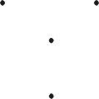

A. 2

B. 3

C. 4

D. 6

4. You have to go through the boxes below, ADDING the points in the white boxes and SUBTRACTING

the points in the shaded ones.

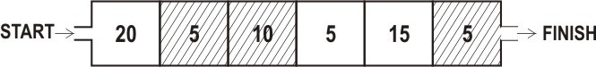

How many points will you have at the end?

A. 20

B. 35

C. 40

D. 60

5. John was sticking stamps in an album. He can stick 5 stamps in each row as shown.

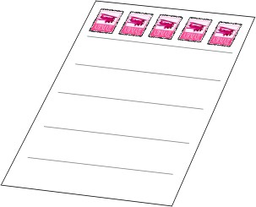

If each page has 6 rows, how many stamps will a page have in all?

A. 5 + 6

B. 6 + 6

C. 5 x 5

D. 5 x 6

6. Ravi wants to get the answer to 4 × 8 but does not know his 4 times table. What could he do to get the answer to 4 × 8?

A. 8 + 4

B. 8 × 8 × 8 × 8

C. 8 + 8 + 8 + 8

D. 4 + 8

7. Mita first bought 33 chocolates for her son Yash's birthday. Later she thought more friends of Yash would come and she bought 15 more chocolates. Yash gave away 40 of the chocolates his mother bought, to his friends.

How many chocolates remained?

A. 0

B. 7

C. 8

D. 25

8. A part of a test paper is shown.

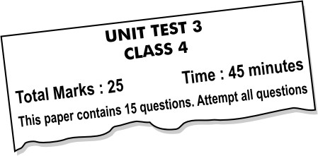

What is the highest score you can get on this test?

A. 15

B. 25

C. 40

D. 45

9. Shown here are the total points of four groups in a class quiz..

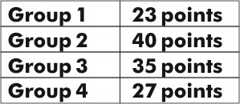

How many points more than Group 4 did Group 2 get?

A. 27

B. 13

C. 8

D. 40

10. Mita has kept her doll next to a tower of blocks.

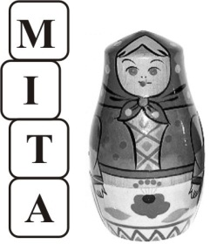

If each block is 10 cm high, about how tall is Mita's doll?

A. 35 cm

B. 25 cm

C. 20 cm

D. 10 cm

11. Look carefully at the calendar below:

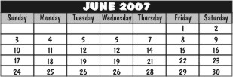

Mihir has a swimming class every Tuesday and tennis coaching every Friday. How many more tennis classes will Mihir have than swimming classes in June?

A. 1

B. 2

C. 3

D. Number of tennis classes would be same as the number of swimming classes.

12. One hand of Pinky's clock has fallen off. Now the clock has ONLY THE HOUR HAND. What could be the time when the clock face is as shown below?

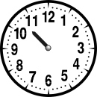

A. 10:00

B. 10:30

C. 11:00

D. 11:30